Charity Pleasure & Trail rides on Sunday 7th November 2021

In aid of Charities: M.S.A. Multiple system atrophy is a progressive neurodegenerative disorder and Cancer Research
The Halloween Ride Part II takes place at
Parsonage Farm Berrick Salome, Wallingford OX10 6JQ
by kind permission of the Landowner Marlene Edwards
Start time: 10.00 onwards with 5 minutes intervals between each pair of riders
Entry: £20 NRC Members & £25 for non NRC.
Closing date for payment 2nd November.
Riders to be 18 years and over.
This trail is especially beautiful at this time of the year. There are many opportunities to have long canters with minimal road work.
There is a choice of a 3 mile marked Pleasure ride, ridden leisurely or
a 6 mile Competitive Trail Ride, the Optimum completion time, 4.4 mph to 7.5mph
for Gold, silver or bronze awards
(Naphill RC members will gain Sommerhalder points)
Refreshments will be available at the end of the ride
If you wish to receive your map/talk round a couple of days before the ride please contact Janet
Parking ... hard standing + grass
To Enter please complete the Booking Slip below
and the Gift Aid Form on the day ... Thank you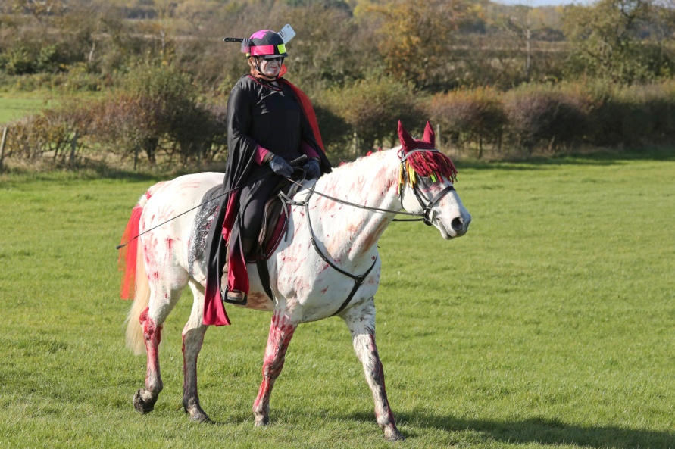
BOOKING SLIP FOR M.S.A. Charity and Cancer Research Trail Ride  Sunday 7th October  Parsonage Farm, Berrick Salome, OX10 6JQ  . . . Janet will email / text to you your start time will be on Friday 5th November  Refreshments will be available at the end of your ride  Entries Close – 2nd November 2021  Please bring with you your mobile, map holder and money.  Rider (18 years and over) : ………………………………….........................................  Horse’s name...............................................................................................................  Address:  ......................................................................................................................................  Affiliated Riding Club / BHS Gold membership number:  …………………..........................……………………………..  Telephone & Mobile no: ...................................................................  Email: ..............................................................................................  Please tick your chosen route:  Pleasure Ride 3 miles O  Trail Ride 6 miles O to be ridden between 6 -7.5 mph  Entry: £20 NRC Members & £25 for non NRC members.  Payment in advance please to: Naphill Riding Club & please use reference: Trail/07-11  Account Number: 70668605 Sort code: 20-40-71  Thank you for your support 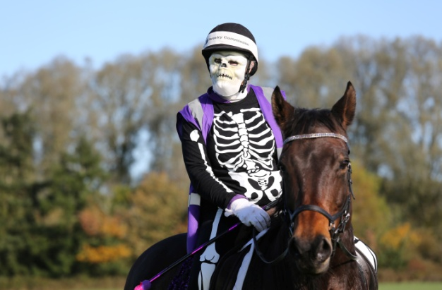 | Send entries to:  Email: mail@janetbayley.co.uk  Please enclose:  1st class SAE for map & talk round

