Naphill Riding Club Pleasure Ride
West Wycombe Park
Sunday 23rd August 2020 From 10.00am
Venue: Meet at Cowleys Field (Car Boot Field), West Wycombe, Bucks. HP14 3BA by kind permission of Sir Edward and Lady Dashwood
Once again we are offering an off road ride on the West Wycombe Estate over scenic farming countryside and parkland and two optional river crossings
To reserve your place call Mary Hilder 07808 808820 or email mary@westwycombeestate.co.uk
Parking on grass. Please clean up after your horse.
You may ride individually or in small groups, set off in 5 minute intervals from 10am
Start Time: 10am Distance: Approx. 8.7 miles with an optional additional loop of 2.8 miles making the long ride 11.5 miles.
Sadly, due to Covid-19 virus, there will not be any refreshments and the toilets will be not available for use. Please keep safe, by keeping your distance from others. You will be shown where to park ... trailers 5 metres apart while lorries 10 metres.
Entry Fee: £15 paid in cash on the day (£10 of your entry fee will be donated to Marie Curie Cancer Care)
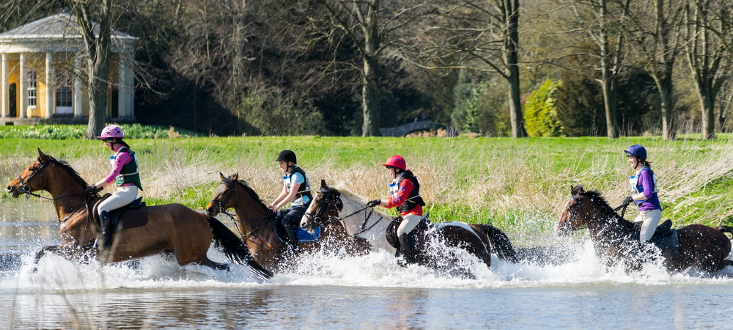

Directions: West Wycombe Park is on the A40 between Stokenchurch and West Wycombe. From M40 Junction 5, the entrance is on the right about 3 miles out of Stokenchurch half a mile after the Dashwood Arms pub.
From High Wycombe, take the A40 through West Wycombe. The entrance is about quarter of a mile on the left after West Wycombe in the lay by.

